MODULE 4 – INTRODUCTION TODBMS

LAB EXERCISES

2. SQL Syntax
Lab 1.
Retrieve all members who joined the library before 2022. Use appropriate SQL syntax with WHERE and ORDER BY.
Ans.
Update the date
1. UPDATE members SET date_of_membership = '2021-05-10' WHERE member_id = 1;
UPDATE members SET date_of_membership = '2020-03-15' WHERE member_id = 2;
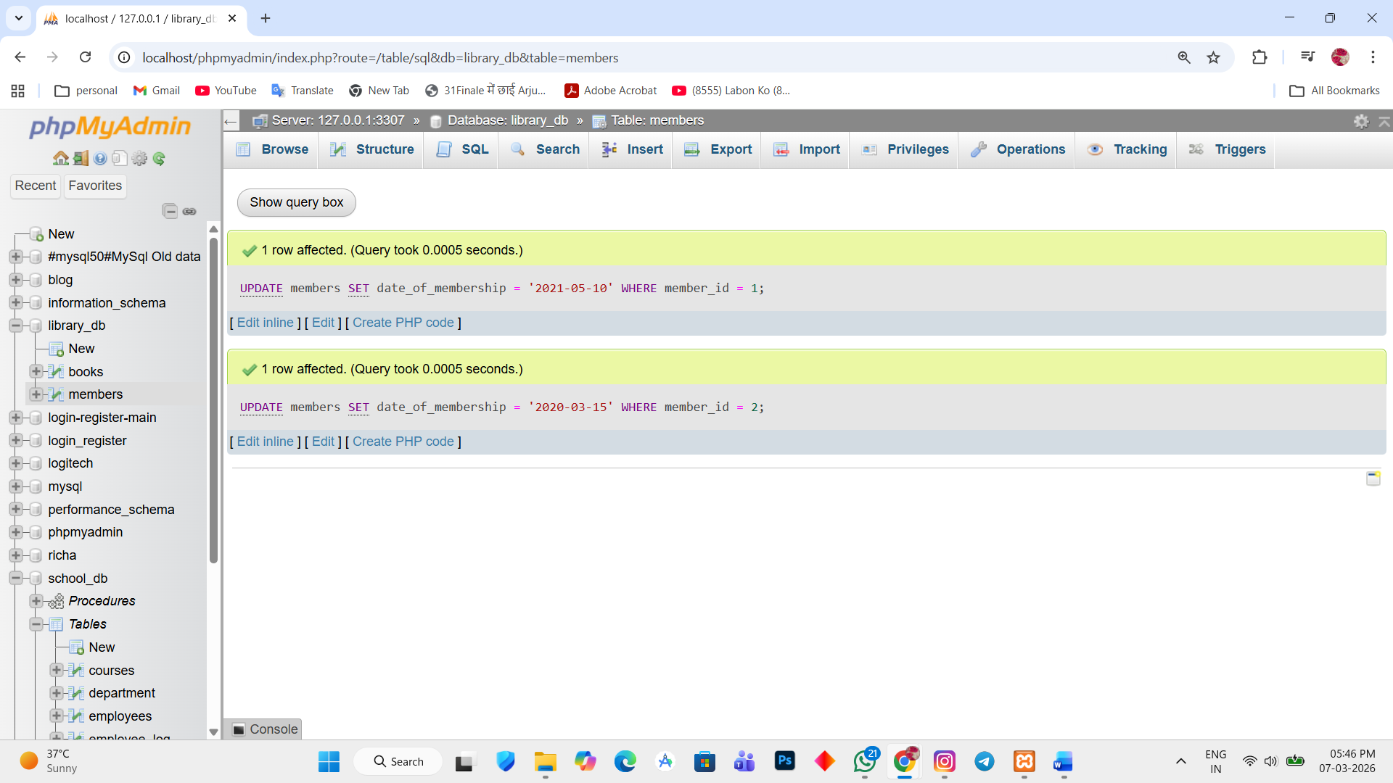

Retrieve member before 2022
2. SELECT * FROM `members` WHERE date_of_membership < '2022-01-01' ORDER BY date_of_membership;

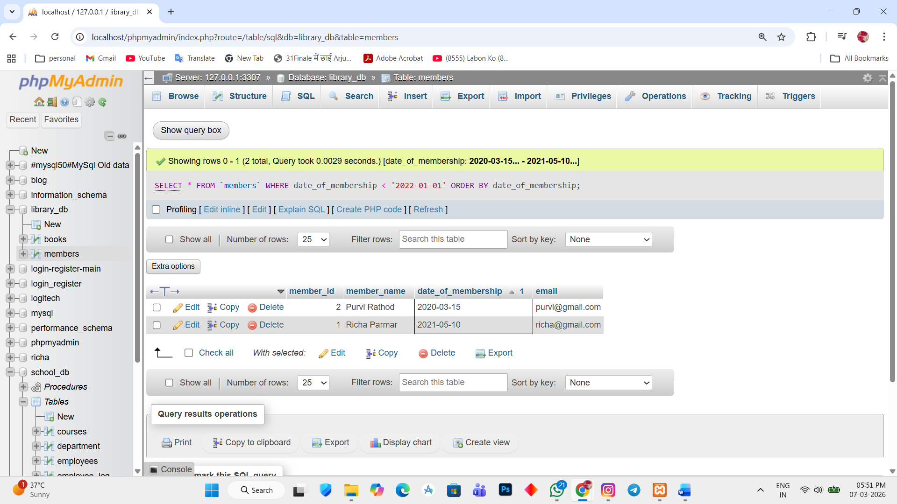

Lab 2.
Write SQL queries to display the title of books published by a specific author. Sort the result by year_of_publication in descending order.
Ans.
1. SELECT title FROM books WHERE author = 'Richa';
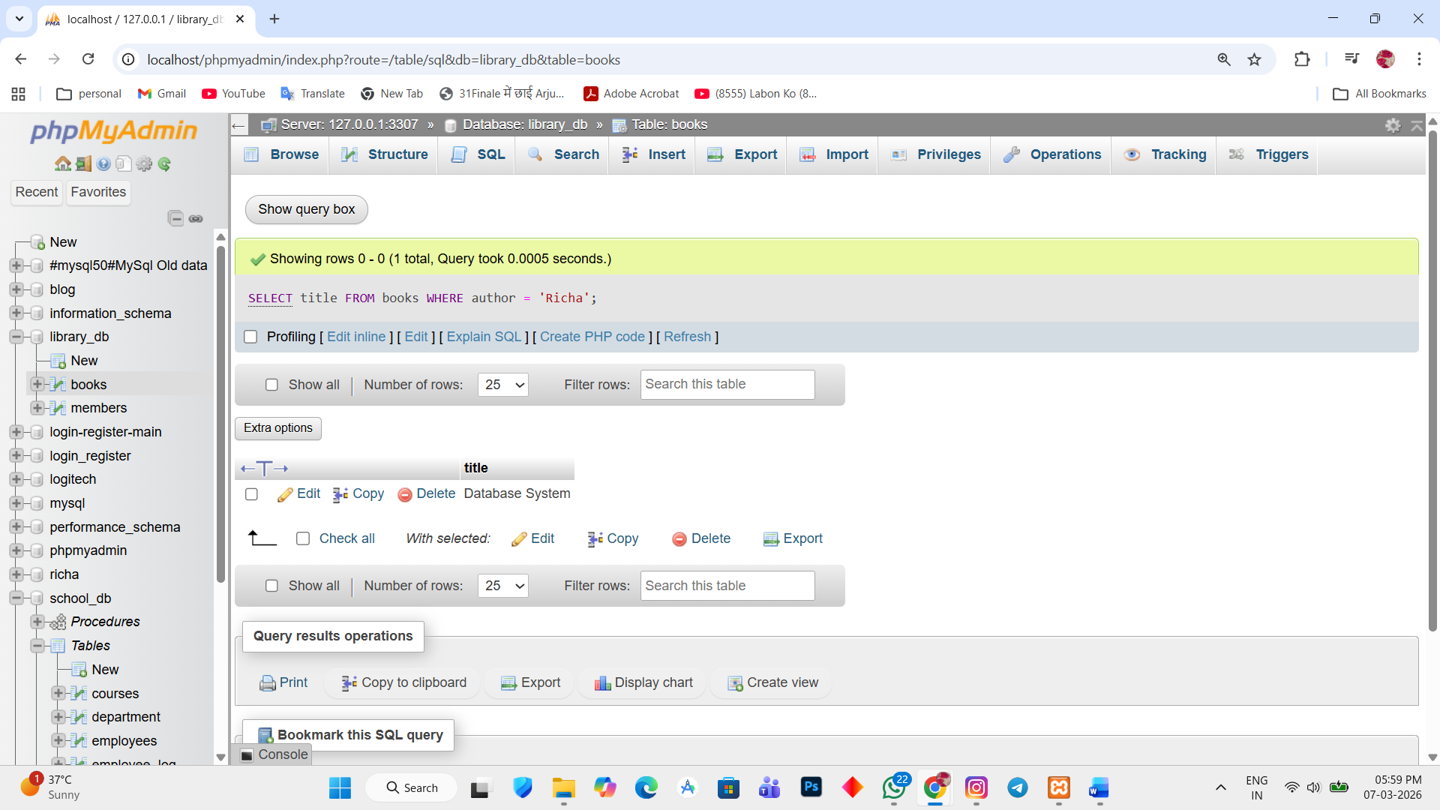

2. SELECT title FROM books ORDER BY year_of_publication DESC;

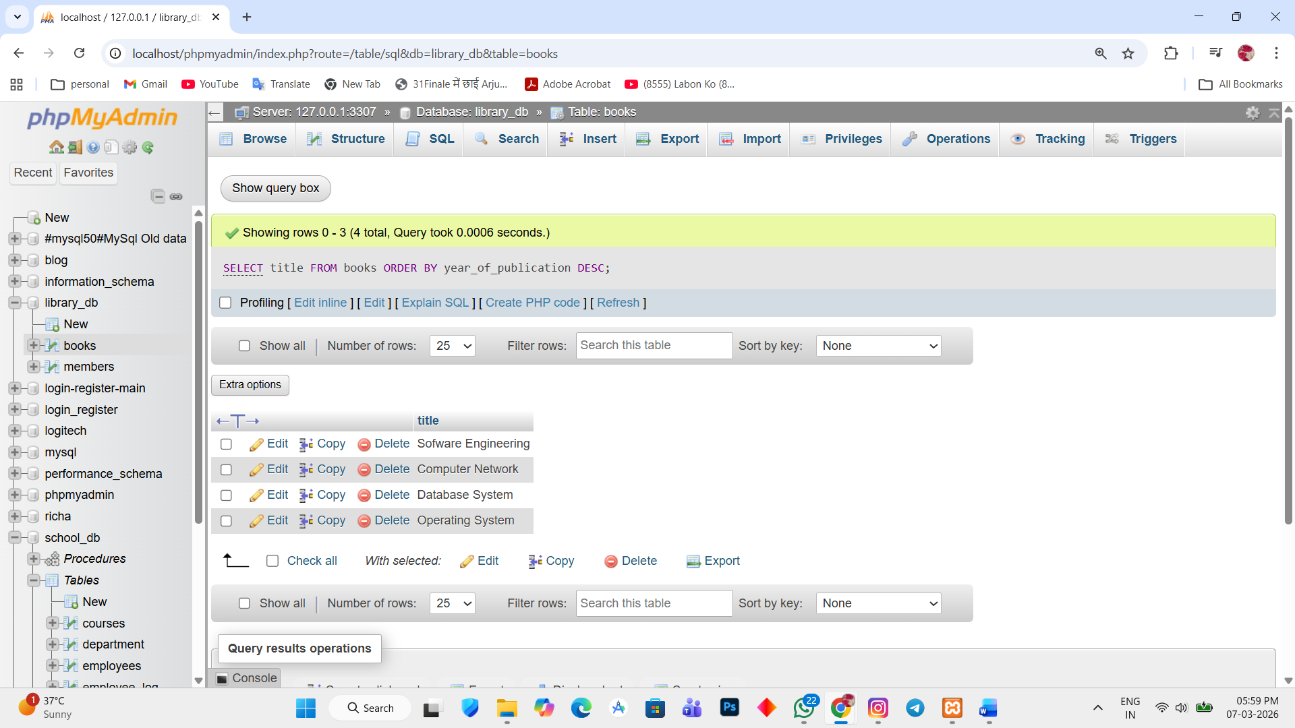

3. SELECT title, year_of_publication FROM books ORDER BY year_of_publication DESC;
